**DATA CLEANING**

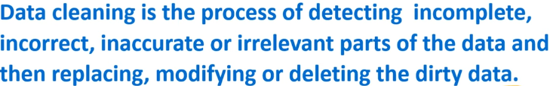

Data cleaning is also called data cleansing. Data cleaning is subset of pre-processing. Data cleaning is necessary for analysis and extraction of insights.

Collection of Data from Multiple Sources

1. Import datasets

2. Merge datasets into one dataset

3. Identify errors

4. Standardize processes

5. Scrub for duplicates

6. Validate accuracy